News from Heshima

Reg charity 1114119
Website: www.heshima.org.uk
Contact: Alan Cram acram@headweb.co.uk 07855259266
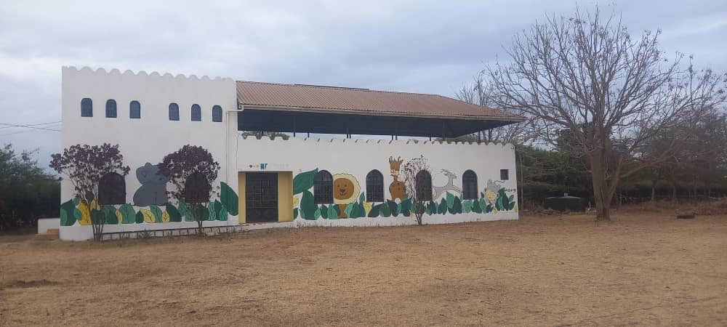
Here is the latest report of the Heshima project in Tanzania. Despite the post-election turmoil and violence, I hope you find this report inspiring. I visited at the end of September.
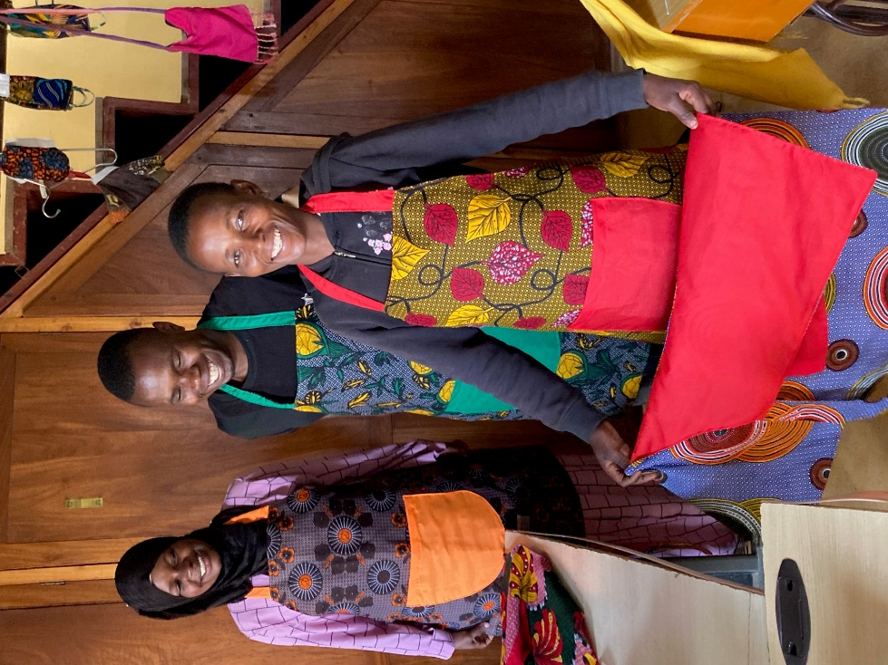
Textile Project: this continues to employ around 6 local Maasai ladies, who continue to make a variety of products: some, such as aprons (see photo) are primarily for customers in the UK (I have a number for purchase @ £10 each), others such as curtains and bed/chair covers are made-to-order, especially for Braeburn International School.
In addition to the 6 trained women, there is a group of trainees who meet daily. At the beginning of the year, the group consisted of 10myoung women: sadly due family pressures (marriage, caring for older relatives or younger siblings etc) the number attending has dropped considerably.
Mwamvita (left, in photo), recently returned from maternity leave, and Adelfina (currently on maternity leave!) continue to supervise both groups, doing a superb job.

Carpentry Project: at last, the carpentry training building is complete (see photo), and we are awaiting a shipment of tools from the UK, due to arrive by the end of the year, although it may be delayed further by the ongoing situation in Tanzania. It is hoped to employ a qualified person who will train local people to make, initially, simple, saleable items. 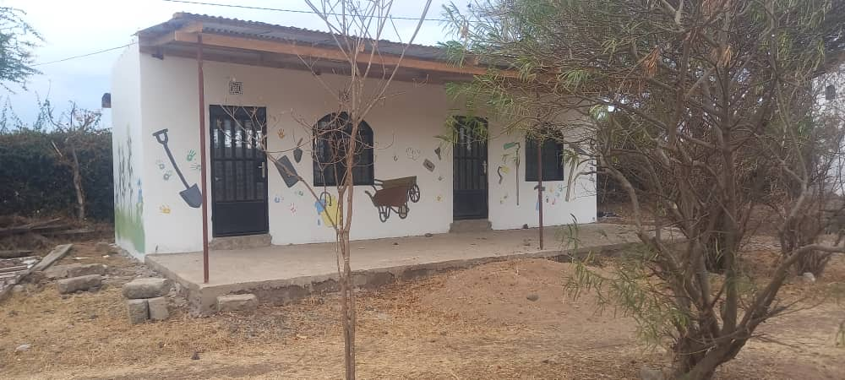
In addition to regular donations from a number of supporters, I managed to obtain significant grants from charitable trusts in the UK which enabled completion of the building and the purchase of equipment.
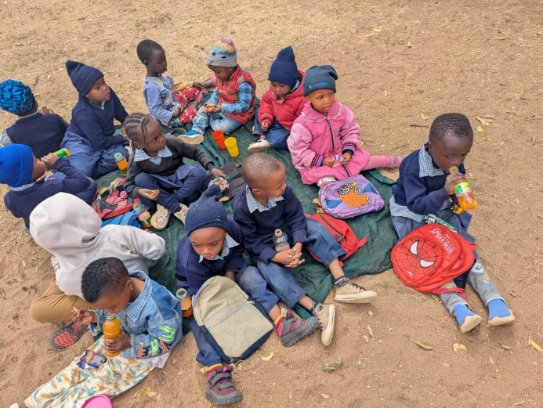
Nursery School: around 15 children continue to meet every weekday morning (see photo) where, under the guidance of Mwamvita, supported by Heshima caretaker Kasioki, the children learn to read and write in both Swahili and English. Sometimes they meet in the classroom, sometimes outside. And of course, there is time for play and refreshments.

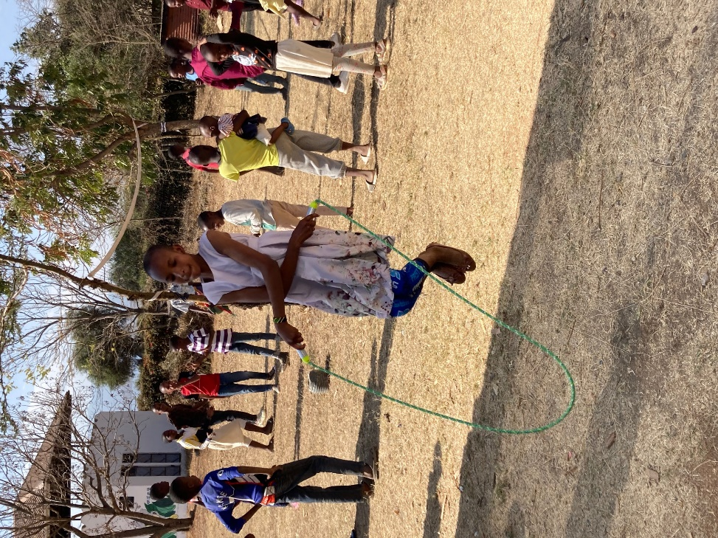
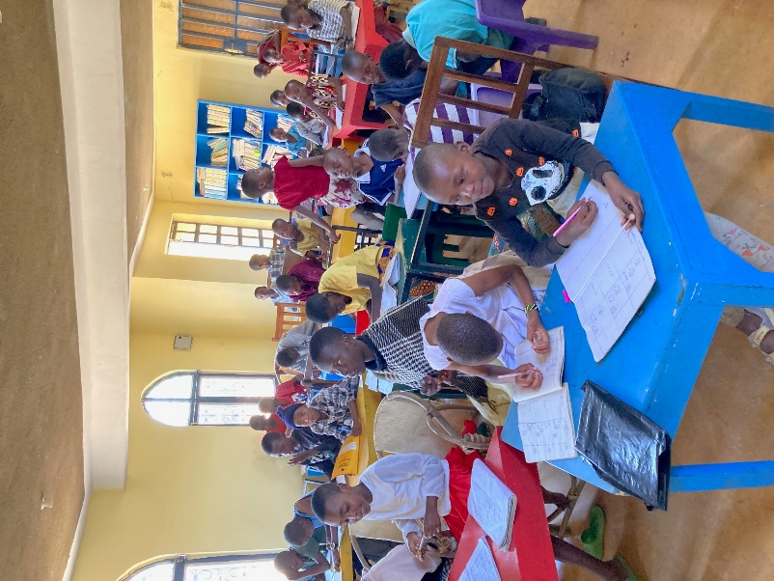
Educational support for older children: every Saturday afternoon, up to 40 local children come to Heshima for additional support in English and Maths, led again by Mwamvita and Kasioki. Most of the children who attend will be moving to secondary school in January, where all lessons are taught in English. This transition is especially difficult for the children since primary education is through the medium of Swahili: hence the importance of this support. After an hour or so of serious work, there is then 60 minutes of games and other fun activities.

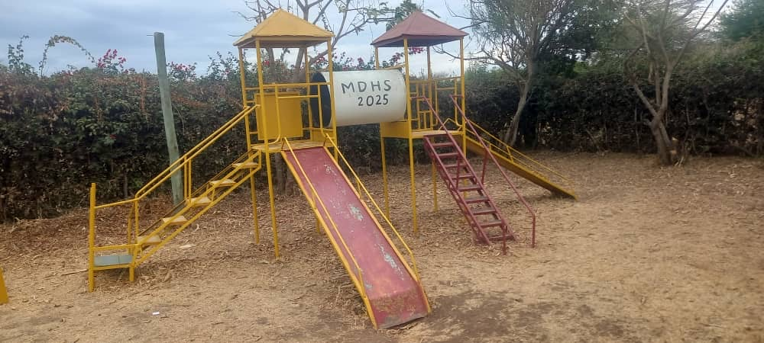
Volunteers: We have been very fortunate in welcoming volunteers to Heshima this year. In July, a group of students from Taiwan stayed for 2 weeks, carrying out all sorts of DIY jobs, including re-building the playground and painting the outside walls of the various buildings.

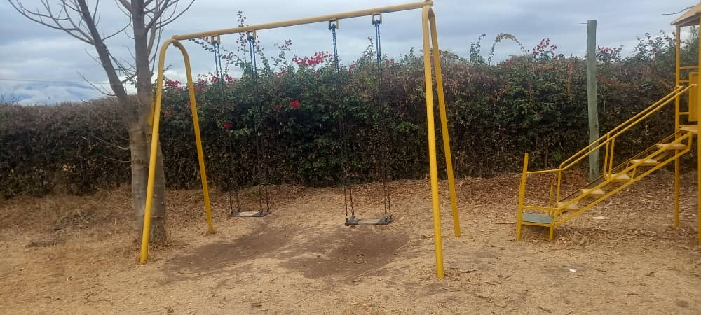

Then in October, Anna, Gabriele and their two boys travelled from Switzerland. Anna is a trained Montessori teacher, and she was able to introduce additional teaching methods. Gabriele was hands-on, doing some painting and servicing the lap-tops. The boys were very happy making new friends! (see over)

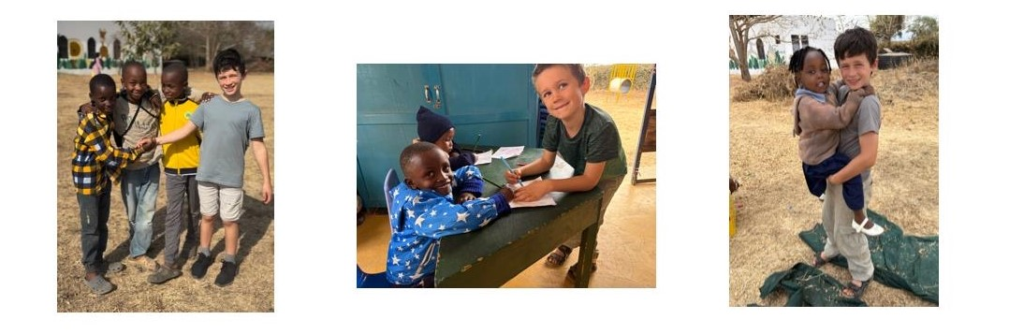
The Grounds: Kasioki does a brilliant job maintaining the grounds—and growing vegetables and fruit. Tanzania is still waiting for the big rains to come, so the ground is very dry, dusty and brown. In addition, the huge underground water tank has sprung a leak, so repair work is a priority in order to take advantage of the rains when they do arrive. 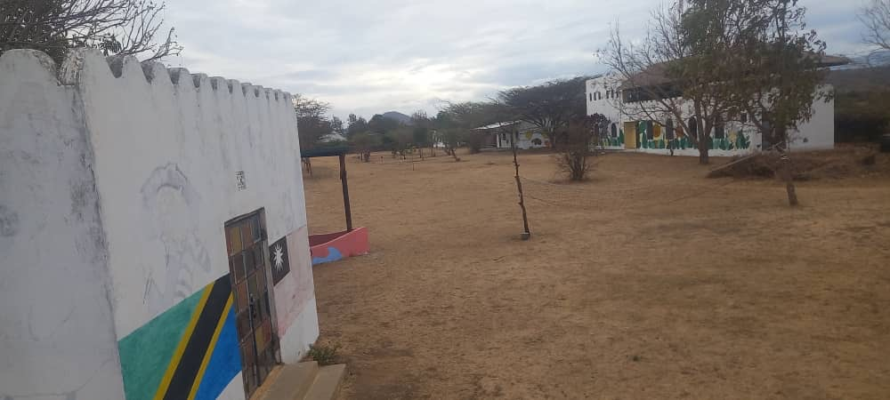
Thank you for reading, taking an interest and/or supporting!
Alan Cram November 2025


